Vessel Name |  |  | Voyage ID
Please return to your appointed agent and the terminal via email shipping@dbct.com.au at least 10 days prior to arrival at the Port.
It is a requirement that all vessels entering the Port of Hay Point be compliant with all applicable International Maritime Organisation (IMO) Environmental Regulations and be able to demonstrate that the vessel does not pose a threat to the environment.
Please ensure that all the Terminal prefilled information (printed in blue font) is verified as valid and correct.
If any prefilled information is changed - write by hand or edit with red font.
Please refer page (4) for Cargo Nomination Advice.
Please review the Vessel Loading Sequence Preparatory Guideline (GD0020) before answering section ‘1. Loading Plan’.
The Initial ETA to Hay Point anchorage is to be advised upon receipt of this questionnaire.
Daily updates are required starting 10 days before arrival.
Initial ETA (time and date)
Master’s Name
Voyage Number for departure from DBCT, Hay Point
Last discharge port and date of departure

- Loading Plan
Please advise required cargo, stowage by holds, loading order and the quantity to be loaded each pour prepared on IMO BLU code format.
1.1 - Berthing / Sailing Displacement | Metric Tonnes
Advise the Berthing Displacement
Instruction - Berthing displacement should not exceed 110,000MT
Advise the Sailing Displacement
1.2 - Deballasting Time Required | Hours
Advise the MINIMUM time required for deballasting including stripping (in hours)
Instruction - Only include the minimum stripping time to pump out while alongside
1.3 - Is a Loading Stop Required for Deballasting Purposes? | Yes / No
Please advise if you require the terminal to stop loading for deballasting and/or stripping prior to the completion of loading. Average loading rate is 7000-6100mtph (5600mtph for geared vessels).
Instruction - Calculate available time for deballasting to the Trimming Draft Check only (not full cargo request).
1.4 - Duration of Required Loading Stop (if applicable) | Hours
Stoppage time required (if applicable) for deballasting and/or stripping
Instruction - If temporarily stopping the loading operation, indicate on the loading sequence plan after which loading step and for how many hours you require the terminal to stop loading for deballasting. Kindly note that time taken for deballasting, will be recorded on the Working Log (time sheet) as 'Deballasting at vessel's request'. Please accurately declare the minimum required time only. Retaining ballast on finish is an option. As best practice, this assists the Terminal in developing the most optimal and best expedited schedule of shipping movements at the Port of Hay Point.
1.5 - Berthing Air Draft | Metres
Distance from the water line to the top of hatch coaming of the first hold to be loaded.
Instruction - The air draft must not exceed 28.5 metres less height of tide at the proposed time of commencement of loading. If the air draft exceeds this, the Shiploader cannot be
positioned and this may result in delays to the commencement of loading.

Vessel Specifications
2.1 - Hatch dimensions (Metres) |  |  |  | 2.2 - Distance between Hatch Centres (Metres)  (Review illustration below for guidance)
Hatch | Length | Width
1 |  |  |  | Hatch 1 centre to Hatch 2 centre:
2 |  |  |  | Hatch 2 centre to Hatch 3 centre:
3 |  |  |  | Hatch 3 centre to Hatch 4 centre:
4 |  |  |  | Hatch 4 centre to Hatch 5 centre:
5 |  |  |  | Hatch 5 centre to Hatch 6 centre:
6 |  |  |  | Hatch 6 centre to Hatch 7 centre:
7 |  |  |  | Hatch 7 centre to Hatch 8 centre:
8 |  |  |  | Hatch 8 centre to Hatch 9 centre:
9

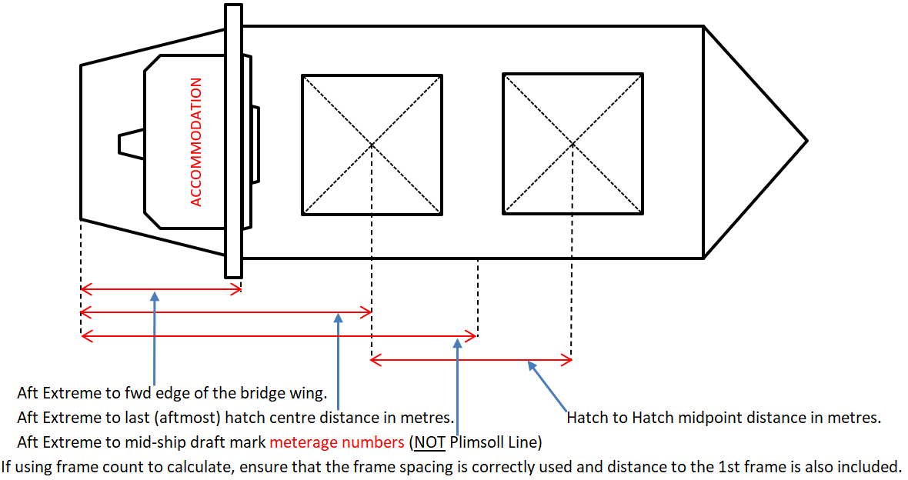

2.3 – Please advise the following distances (In Metres NOT Frame Distance)  (Review illustration above for guidance) | Metres
2.3.1 Aft Extreme to forward edge of the bridge wing extension
2.3.2 Aft Extreme to the Last (Aftmost) hatch centre distance
2.3.3 Aft Extreme to the Mid-Ship Draft Mark meterage numbers (NOT Plimsoll Line)

2.4 - Hold Cubic Capacity m³  (incl. hatchway/ coaming volume) |  | 2.5 - Max Individual  Hold Weight Limit (MT)  Vessel Construction Limits MT  (not MT/m²) Independent of Cargo Density |  | 2.6 - Max Adjacent (combined)  Hold Weight Limit (MT)  Vessel Construction Limits MT  (not MT/m2) Independent of Cargo Density
Hold 1 |  | Hold 1 |  | Hold 1 and 2
Hold 2 |  | Hold 2 |  | Hold 2 and 3
Hold 3 |  | Hold 3 |  | Hold 3 and 4
Hold 4 |  | Hold 4 |  | Hold 4 and 5
Hold 5 |  | Hold 5 |  | Hold 5 and 6
Hold 6 |  | Hold 6 |  | Hold 6 and 7
Hold 7 |  | Hold 7 |  | Hold 7 and 8
Hold 8 |  | Hold 8 |  | Hold 8 and 9
Hold 9 |  | Hold 9 |  | *if available or applicable

Summer DWT |  | GRT |  | NRT
LOA |  | Beam |  | Summer Draft
Summer TPC |  | Constant |  | IMO #
Call Sign |  | Port of Registry |  | Flag State
Telephone
Email

2.7 - Vessel Deck Obstructions |  |  | Metres
Instruction – Please advise minimum distance between deck obstructions, i.e. cranes, light masts, etc. (in metres, NOT frame distance x No. of frames):
Deck Obstructions:
2.8 - Vessel Cargo Box |  |  | Metres
Length of the cargo loading box (forward coaming 1st hatch to aft coaming last hatch in metres [NOT frame distance x No. of frames])
2.9 - Pilot Helicopter Compliance |  |  | Yes / No
Can vessel accept a land on helicopter?
Instruction - Vessel must comply with AMSA Marine Order 57 (Helicopter Operations) and subsequent amendments.

2.10 - Cargo Holds Preparation |  |  | Yes / No
Confirm all cargo holds will be clean, dry, safe and ready in all respects to load with no crew or other personnel in holds or bilges.
Instruction - Please ensure 1st loading hatch is open once vessel is all fast/secure.
2.11 - Vessel Obstructions |  |  | Yes / No
Do any fixed obstructions, ship’s gangways / accommodation ladders (in fully stowed position) protrude beyond the ship’s side? If Yes, state details of obstructions and highlight on the GA plan.
Vessel Obstructions:
Instruction - Please submit the vessel’s General Arrangement deck plan.
Submission required for terminal records / On File
Instruction - Please submit the Ship’s Particulars.
Instruction - Open hatch covers cannot protrude beyond the ship side. The complete length of the hatch, including rack ends and cleat locations, must be secured within the outboard extreme of the vessel to prevent getting caught on shore fenders and derailed from hatch runners.
Instruction - All Davit and/or Luffing cranes (incl. the jib’s far end sheave) on the main deck for stores/provisions and other activities, inside the hold box area, must remain completely clear of the hold opening space across the Length, Beam and Height extreme of the vessel as this is the Ship Loader’s operating area.
Instruction - On deck collapsible light towers are preferred to be in their lowered and stowed position.
2.12 - Gas, Temperature and pH Monitoring Information |  |  | Yes / No
Confirm vessel has means for measuring concentration of methane, oxygen, carbon monoxide, temperatures in cargo spaces, pH value of hold/bilge samples.

2.13 - Dangerous Goods Information | Yes / No
Please advise if your vessel is already part loaded with dangerous goods in bulk (MHB)
2.13.1 Cargo Name and load port
2.13.2 IMO Class and UN/BC number
2.13.3 Quantity (prestow or actual)
- Mooring Ropes

Mooring Ropes | Answer
3.1 Total coils on board incl. spares
3.2 Type (Material)
3.3 Condition of lines
3.4 Number of lines run on main winch
(tension drum only- NOT on warping drum end or capstan tensioned only)
3.5 Number of lines run on bollard or bitts
(NOT on main winch tension drum)
3.6 Confirm mooring lines have valid certificates and are inspected every 3 months and be presented in good condition
3.7 Confirm reciprocal mooring lines (eg headlines and sternlines, fore and
aft springs, or fore and aft breastlines) of the same type and
construction and have a similar (+/-10%) Line Design Break Force
3.8 Confirm winch brake render set point at 60% of ship design MBL.
3.9 Confirm quality manufactured chafe protection is fitted on all ship's
lines at vessel structure contact points, eg fairleads/chocks
3.10 Confirm that fairleads, chocks and bitts are well maintained and free
from rust or abrasive surfaces
Instruction - Mooring Ropes must be HMPE or synthetic or similar floating type only. Wire mooring lines are NOT acceptable. HMPE lines are required to be fitted with tails 11m in length.

- Cargo Nomination Advice
Shipper | Parcel | Cargo Description |  | Product | Nominal Tonnes Planned | Min Tonnes | Max Tonnes | Laycan Start | Laycan End | Stowage  Factor * (cu.ft./mt)
Total
* the Stowage Factor is declared as a guide only

5. Terminal Pre Arrival and Safety Information Review

5.1 Please acknowledge review of the following critical Dalrymple Bay Coal Terminal Pty Ltd procedures and presentation | Yes / No
5.1.1 Terminal Information Booklet
Access via Dalrymple Bay Coal Terminal Website - Shipping Information Page
Click link below
Terminal Information Booklet Procedure (squarespace.com)

5.1.2 DBCT Safety Video Presentation
Access via Dalrymple Bay Coal Terminal Website - Shipping Information Page
Link Under Mooring Line Requirements - Please download the Presentation
Click link below
Shipping Information — Dalrymple Bay Coal Terminal (dbct.com.au)
Password : DBCTShipping

5.1.3 Terminal Regulations Procedure
Access via Dalrymple Bay Infrastructure (DBI) Website
https://dbinfrastructure.com.au/wp-content/uploads/2018/06/TerminalRegulations.pdf
Click link below
https://dbinfrastructure.com.au/wp-content/uploads/2018/06/TerminalRegulations.pdf

